TI DSP, MCU 및 Xilinx Zynq FPGA
프로그래밍 전문가 과정

강사 – lnnova Lee(이상훈)
gcccompil3r@gmail.com
학생 – 하성용
accept0108@naver.com

53일차
http://hputty.org/

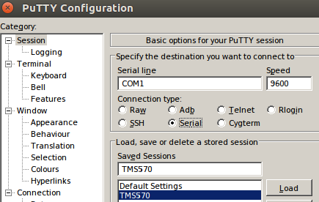

//putty 비설치 옵션 설정 - TMS570은 추가

HALCoGen 실행

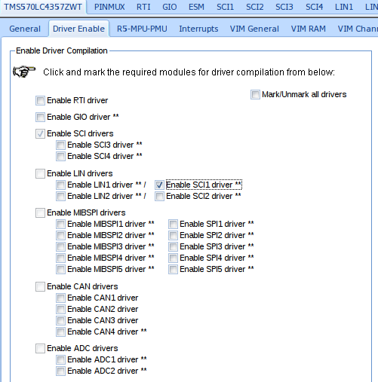

CCS 실행
옵션넣기 "${workspace_loc:/${ProjName}/include}"

#include "HL_sys_common.h"
#include "HL_system.h"
#include "HL_sci.h"

#define TSIZE1 6
uint8 TEXT1[TSIZE1] = {'H', 'E', 'L', 'L', 'O', ' '};
#define TSIZE2 12
uint8 TEXT2[TSIZE2] = {'T', 'I', ' ', 'H', 'E', 'R', 'C', 'U', 'L', 'E', 'S', ' '};
#define TSIZE3 12
uint8 TEXT3[TSIZE3] = {'S', 'A', 'F', 'E', 'T', 'Y', ' ', 'M', 'C', 'U', '\n', '\r'};

void sciDisplayText(sciBASE_t *sci, uint8 *text, uint32 length);
void wait(uint32 time);

#define UART sciREG1

int main(void)
{
sciInit();

for(;;)
{
sciDisplayText(UART, &TEXT1[0], TSIZE1);
sciDisplayText(UART, &TEXT2[0], TSIZE2);
sciDisplayText(UART, &TEXT3[0], TSIZE3);
wait(200);
}

return 0;
}

void sciDisplayText(sciBASE_t *sci, uint8 *text, uint32 length)
{
while(length--)
{
while((UART->FLR & 0x4) == 4)
;
sciSendByte(UART, *text++);
}
}

void wait(uint32 time)
{
int i;

for(i = 0; i < time; i++)
;
}

– – – – – – – – – – – – – – – – – – – – – – – – – – – – – – – – – – –
UART_PWM //0~6까지 집어넣으면 서브모터가 각도가바뀌는소스
/home/yong/workspace_v8/UART_PWM

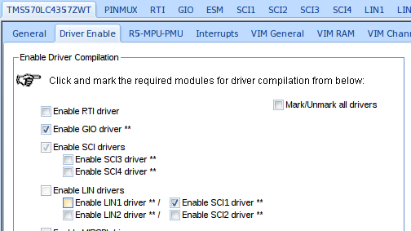

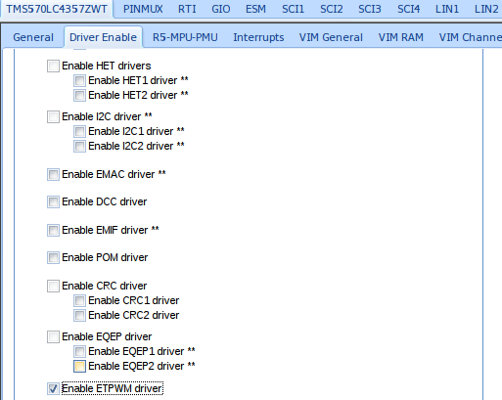

//드라이버

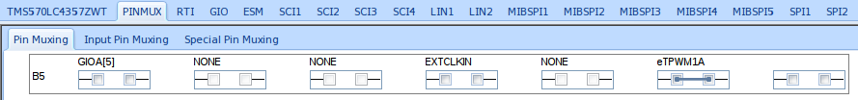
//핀먹스

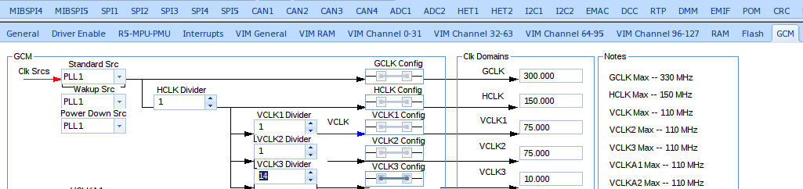
//GCM – VCLK3 → 14

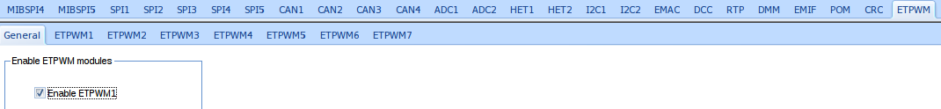
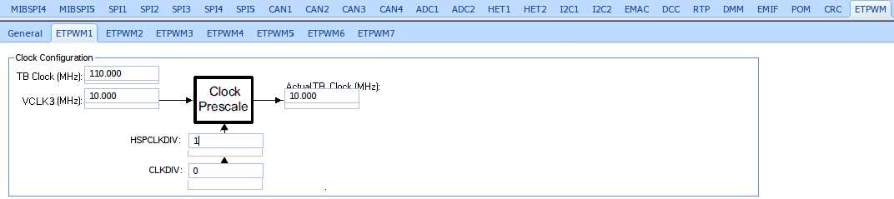
//ETPWM - ETPWM1 – SPCLKEW->1

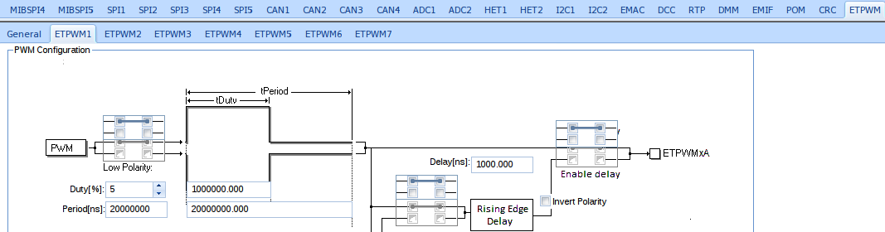

//Duty, Period 설정

→ Generate code

#include "HL_sys_common.h"
#include "HL_system.h"
#include "HL_etpwm.h"
#include "HL_sci.h"

#include <string.h>
#include <stdio.h>

#define UART sciREG1

void sciDisplayText(sciBASE_t *sci, uint8 *text, uint32 len);
void pwmSet(void);
void wait(uint32 delay);

uint32 rx_data = 0;
uint32 tmp = 0;
uint32 value = 0;

#define IDX 6
uint32 duty_arr[IDX] = {1000, 1200, 1400, 1600, 1800, 2000};

int main(void)
{
char txt_buf[256] = {0};
unsigned int buf_len;

sciInit();

sprintf(txt_buf, "SCI Configuration Success!!\n\r");
buf_len = strlen(txt_buf);
sciDisplayText(sciREG1, (uint8 *)txt_buf, buf_len);
wait(1000000);

etpwmInit();

sprintf(txt_buf, "ETPWM Configuration Success!!\n\r");
buf_len = strlen(txt_buf);
sciDisplayText(sciREG1, (uint8 *)txt_buf, buf_len);

etpwmStartTBCLK();
wait(1000000);

sprintf(txt_buf, "Please Press Key(0 ~ 5)!!\n\r");
buf_len = strlen(txt_buf);
sciDisplayText(sciREG1, (uint8 *)txt_buf, buf_len);
wait(1000000);

for(;;)
{
tmp = sciReceiveByte(UART);
rx_data = tmp - 48;

sprintf(txt_buf, "rx = %d\n\r\0", rx_data);
buf_len = strlen(txt_buf);
sciDisplayText(sciREG1, (uint8 *)txt_buf, buf_len);

pwmSet();

sprintf(txt_buf, "PWM Duty = %d\n\r\0", value);
buf_len = strlen(txt_buf);
sciDisplayText(sciREG1, (uint8 *)txt_buf, buf_len);
}

return 0;
}

return 0;
void pwmSet(void)
{
value = duty_arr[rx_data];
etpwmSetCmpA(etpwmREG1, value);
wait(10000);
}

void wait(uint32 delay)
{
int i;

for(i = 0; i < delay; i++)
;
}

void sciDisplayText(sciBASE_t *sci, uint8 *text, uint32 len)
{
while(len--)
{
while((UART->FLR & 0x4) == 4)
;
sciSendByte(UART, *text++);
}
}

//putty는 포트설정해야 할수있음

//UART 프로그램 해석

mpu 6050?

//
css실행
I2C_MPU6050

/home/yong/workspace_v8/I2C_MPU6050

할코겐 실행

gio//동작을 하는지 안하는지 여부

UART 잘안될때 해결 : 뺏다 꼽으면 된다

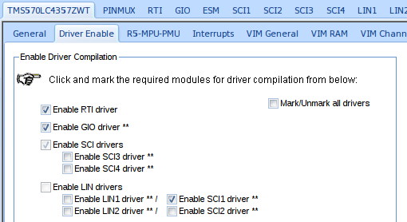

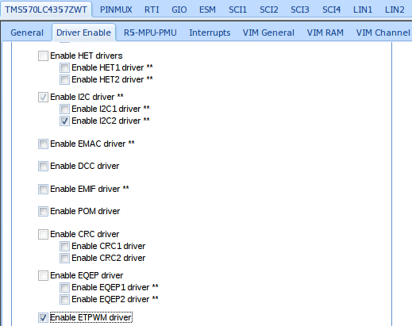

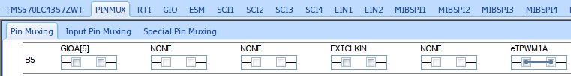
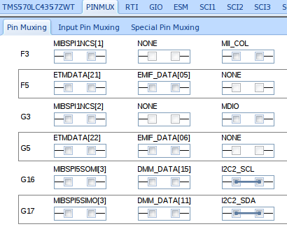

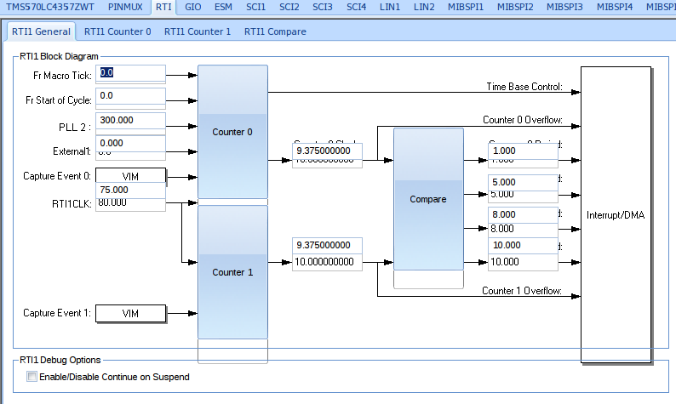

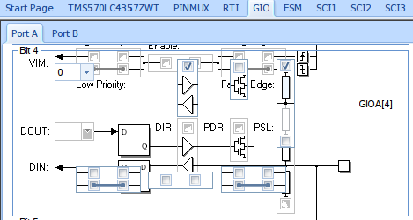

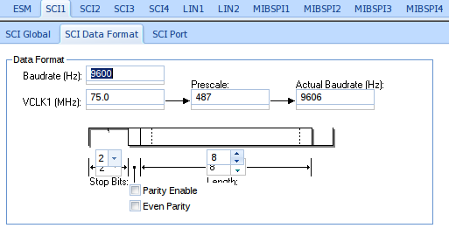

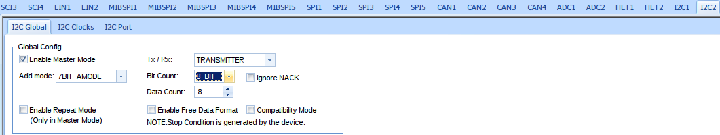

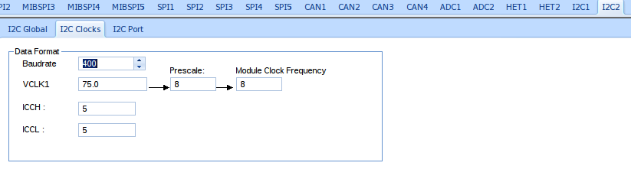

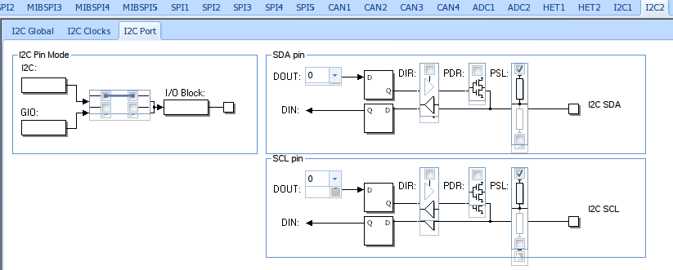
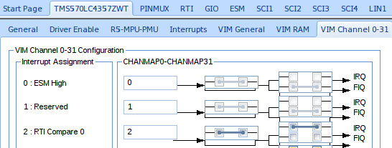
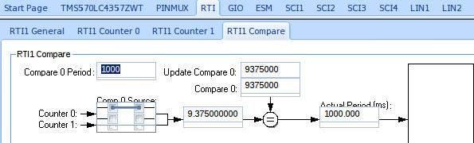
→ Generate code

#include "HL_sys_common.h"
#include "HL_system.h"
#include "HL_etpwm.h"
#include "HL_sci.h"
#include "HL_gio.h"
#include "HL_i2c.h"
#include "HL_rti.h"

#include <string.h>
#include <stdio.h>

#define UART sciREG1
#define MPU6050_ADDR 0x68

void sciDisplayText(sciBASE_t *sci, uint8 *text, uint32 len);
void pwmSet(void);
void wait(uint32 delay);

void MPU6050_enable(void);
void MPU6050_acc_config(void);

uint32 rx_data = 0;
uint32 tmp = 0;
uint32 value = 0;

volatile char g_acc_xyz[6];
volatile int g_acc_flag;

#define IDX 6
uint32 duty_arr[IDX] = {1000, 1200, 1400, 1600, 1800, 2000};

int main(void)
{
char txt_buf[256] = {0};
unsigned int buf_len;
volatile int i;
signed short acc_x, acc_y, acc_z;
double real_acc_x, real_acc_y, real_acc_z;

sciInit();

sprintf(txt_buf, "SCI Configuration Success!!\n\r\0");
buf_len = strlen(txt_buf);
sciDisplayText(sciREG1, (uint8 *)txt_buf, buf_len);
wait(10000000);

gioInit();

sprintf(txt_buf, "GIO Init Success!!\n\r\0");
buf_len = strlen(txt_buf);
sciDisplayText(sciREG1, (uint8 *)txt_buf, buf_len);
wait(10000000);

i2cInit();
wait(10000000);

MPU6050_enable();
sprintf(txt_buf, "MPU6050 Enable Success!!\n\r\0");
buf_len = strlen(txt_buf);
sciDisplayText(sciREG1, (uint8 *)txt_buf, buf_len);
wait(300);

MPU6050_acc_config();
sprintf(txt_buf, "MPU6050 Accelerometer Configure Success!!\n\r\0");
buf_len = strlen(txt_buf);
sciDisplayText(sciREG1, (uint8 *)txt_buf, buf_len);
wait(300);

rtiInit();
rtiEnableNotification(rtiREG1, rtiNOTIFICATION_COMPARE0);
_enable_IRQ_interrupt_();
rtiStartCounter(rtiREG1, rtiCOUNTER_BLOCK0);

sprintf(txt_buf, "RTI Init Success!!\n\r\0");
buf_len = strlen(txt_buf);
sciDisplayText(sciREG1, (uint8 *)txt_buf, buf_len);

etpwmInit();

sprintf(txt_buf, "ETPWM Configuration Success!!\n\r\0");
buf_len = strlen(txt_buf);
sciDisplayText(sciREG1, (uint8 *)txt_buf, buf_len);

etpwmStartTBCLK();
wait(10000000);

sprintf(txt_buf, "Please Press Key(0 ~ 5)!!\n\r\0");
buf_len = strlen(txt_buf);
sciDisplayText(sciREG1, (uint8 *)txt_buf, buf_len);
wait(1000000);

for(;;)
{
if(g_acc_flag)
{
acc_x = acc_y = acc_z = 0;
real_acc_x = real_acc_y = real_acc_z = 0.0;

acc_x = g_acc_xyz[0];
acc_x = acc_x << 8;
acc_x |= g_acc_xyz[1];
real_acc_x = ((double)acc_x) / 2048.0;

acc_y = g_acc_xyz[2];
acc_y = acc_y << 8;
acc_y |= g_acc_xyz[3];
real_acc_y = ((double)acc_y) / 2048.0;

acc_z = g_acc_xyz[4];
acc_z = acc_z << 8;
acc_z |= g_acc_xyz[5];
real_acc_z = ((double)acc_z) / 2048.0;

sprintf(txt_buf, "acc_x = %2.5lf\tacc_y = %2.5lf\tacc_z = %2.5lf\n\r\0",real_acc_x, real_acc_y, real_acc_z);
buf_len = strlen(txt_buf);
sciDisplayText(sciREG1, (uint8 *)txt_buf, buf_len);

g_acc_flag = 0;
}
}

#if 0
for(;;)
{
tmp = sciReceiveByte(UART);
rx_data = tmp - 48;

sprintf(txt_buf, "rx = %d\n\r\0", rx_data);
buf_len = strlen(txt_buf);
sciDisplayText(sciREG1, (uint8 *)txt_buf, buf_len);

pwmSet();

sprintf(txt_buf, "PWM Duty = %d\n\r\0", value);
buf_len = strlen(txt_buf);
sciDisplayText(sciREG1, (uint8 *)txt_buf, buf_len);
}
#endif

return 0;
}

void pwmSet(void)
{
value = duty_arr[rx_data];
etpwmSetCmpA(etpwmREG1, value);
wait(10000);
}

void wait(uint32 delay)
{
int i;

for(i = 0; i < delay; i++)
;
}

void sciDisplayText(sciBASE_t *sci, uint8 *text, uint32 len)
{
while(len--)
{
while((UART->FLR & 0x4) == 4)
;
sciSendByte(UART, *text++);
}
}

void MPU6050_enable(void)
{
volatile unsigned int cnt = 2;
unsigned char data[2] = {0x00U, 0x00U};
unsigned char slave_word_address = 0x6bU;

i2cSetSlaveAdd(i2cREG2, MPU6050_ADDR);
i2cSetDirection(i2cREG2, I2C_TRANSMITTER);
i2cSetCount(i2cREG2, cnt + 1);
i2cSetMode(i2cREG2, I2C_MASTER);
i2cSetStop(i2cREG2);
i2cSetStart(i2cREG2);
i2cSendByte(i2cREG2, slave_word_address);
i2cSend(i2cREG2, cnt, data);

while(i2cIsBusBusy(i2cREG2) == true)
;
while(i2cIsStopDetected(i2cREG2) == 0)
;
i2cClearSCD(i2cREG2);

wait(1000000);
}

void MPU6050_acc_config(void)
{
volatile unsigned int cnt = 1;
unsigned char data[1] = {0x18U};
unsigned char slave_word_address = 0x1cU;

i2cSetSlaveAdd(i2cREG2, MPU6050_ADDR);
i2cSetDirection(i2cREG2, I2C_TRANSMITTER);
i2cSetCount(i2cREG2, cnt + 1);
i2cSetMode(i2cREG2, I2C_MASTER);
i2cSetStop(i2cREG2);
i2cSetStart(i2cREG2);
i2cSendByte(i2cREG2, slave_word_address);
i2cSend(i2cREG2, cnt, data);

while(i2cIsBusBusy(i2cREG2) == true)
;
while(i2cIsStopDetected(i2cREG2) == 0)
;
i2cClearSCD(i2cREG2);

wait(1000000);
}

void rtiNotification(rtiBASE_t *rtiREG, uint32 notification)
{
unsigned char slave_word_address = 0x3B;

i2cSetSlaveAdd(i2cREG2, MPU6050_ADDR);
i2cSetDirection(i2cREG2, I2C_TRANSMITTER);
i2cSetCount(i2cREG2, 1);
i2cSetMode(i2cREG2, I2C_MASTER);
i2cSetStop(i2cREG2);
i2cSetStart(i2cREG2);
i2cSendByte(i2cREG2, slave_word_address);

while(i2cIsBusBusy(i2cREG2) == true)
;
while(i2cIsStopDetected(i2cREG2) == 0)
;
i2cClearSCD(i2cREG2);

i2cSetDirection(i2cREG2, I2C_RECEIVER);
i2cSetCount(i2cREG2, 6);
i2cSetMode(i2cREG2, I2C_MASTER);
i2cSetStart(i2cREG2);

i2cReceive(i2cREG2, 6, (unsigned char *)g_acc_xyz);
i2cSetStop(i2cREG2);

while(i2cIsBusBusy(i2cREG2) == true)
;
while(i2cIsStopDetected(i2cREG2) == 0)
;
i2cClearSCD(i2cREG2);

g_acc_flag = 1;
}

// 최적화 소스
//
#include "HL_sys_common.h"
#include "HL_system.h"
#include "HL_etpwm.h"
#include "HL_sci.h"
#include "HL_gio.h"
#include "HL_i2c.h"
#include "HL_rti.h"

#include <string.h>
#include <stdio.h>

#define UART sciREG1
#define MPU6050_ADDR 0x68

void sciDisplayText(sciBASE_t *sci, uint8 *text, uint32 len);
void pwmSet(void);
void wait(uint32 delay);

void MPU6050_enable(void);
void MPU6050_acc_config(void);

void disp_set(char *);

uint32 rx_data = 0;
uint32 tmp = 0;
uint32 value = 0;

volatile char g_acc_xyz[6];
volatile int g_acc_flag;

#define IDX 6
uint32 duty_arr[IDX] = {1000, 1200, 1400, 1600, 1800, 2000};

int main(void)
{
char txt_buf[256] = {0};
unsigned int buf_len;
volatile int i;
signed short acc_x, acc_y, acc_z;
double real_acc_x, real_acc_y, real_acc_z;

sciInit();

disp_set("SCI Configuration Success!!\n\r\0");

gioInit();

disp_set("GIO Init Success!!\n\r\0");

i2cInit();
wait(10000000);

MPU6050_enable();

disp_set("MPU6050 Enable Success!!\n\r\0");

MPU6050_acc_config();

disp_set("MPU6050 Accelerometer Configure Success!!\n\r\0");

rtiInit();
rtiEnableNotification(rtiREG1, rtiNOTIFICATION_COMPARE0);
_enable_IRQ_interrupt_();
rtiStartCounter(rtiREG1, rtiCOUNTER_BLOCK0);

disp_set("RTI Init Success!!\n\r\0");

etpwmInit();

disp_set("ETPWM Configuration Success!!\n\r\0");

etpwmStartTBCLK();
wait(1000000);

for(;;)
{
if(g_acc_flag)
{
acc_x = acc_y = acc_z = 0;
real_acc_x = real_acc_y = real_acc_z = 0.0;

acc_x = g_acc_xyz[0];
acc_x = acc_x << 8;
acc_x |= g_acc_xyz[1];
real_acc_x = ((double)acc_x) / 2048.0;

acc_y = g_acc_xyz[2];
acc_y = acc_y << 8;
acc_y |= g_acc_xyz[3];
real_acc_y = ((double)acc_y) / 2048.0;

acc_z = g_acc_xyz[4];
acc_z = acc_z << 8;
acc_z |= g_acc_xyz[5];
real_acc_z = ((double)acc_z) / 2048.0;

sprintf(txt_buf, "acc_x = %2.5lf\tacc_y = %2.5lf\tacc_z = %2.5lf\n\r\0",
real_acc_x, real_acc_y, real_acc_z);
buf_len = strlen(txt_buf);
sciDisplayText(sciREG1, (uint8 *)txt_buf, buf_len);

g_acc_flag = 0;
}
}

#if 0
for(;;)
{
tmp = sciReceiveByte(UART);
rx_data = tmp - 48;

sprintf(txt_buf, "rx = %d\n\r\0", rx_data);
buf_len = strlen(txt_buf);
sciDisplayText(sciREG1, (uint8 *)txt_buf, buf_len);

pwmSet();

sprintf(txt_buf, "PWM Duty = %d\n\r\0", value);
buf_len = strlen(txt_buf);
sciDisplayText(sciREG1, (uint8 *)txt_buf, buf_len);
}
#endif

return 0;
}

void pwmSet(void)
{
value = duty_arr[rx_data];
etpwmSetCmpA(etpwmREG1, value);
wait(10000);
}

void wait(uint32 delay)
{
int i;

for(i = 0; i < delay; i++)
;
}

void sciDisplayText(sciBASE_t *sci, uint8 *text, uint32 len)
{
while(len--)
{
while((UART->FLR & 0x4) == 4)
;
sciSendByte(UART, *text++);
}
}

void MPU6050_enable(void)
{
volatile unsigned int cnt = 2;
unsigned char data[2] = {0x00U, 0x00U};
unsigned char slave_word_address = 0x6bU;

i2cSetSlaveAdd(i2cREG2, MPU6050_ADDR);
i2cSetDirection(i2cREG2, I2C_TRANSMITTER);
i2cSetCount(i2cREG2, cnt + 1);
i2cSetMode(i2cREG2, I2C_MASTER);
i2cSetStop(i2cREG2);
i2cSetStart(i2cREG2);
i2cSendByte(i2cREG2, slave_word_address);
i2cSend(i2cREG2, cnt, data);

while(i2cIsBusBusy(i2cREG2) == true)
;
while(i2cIsStopDetected(i2cREG2) == 0)
;
i2cClearSCD(i2cREG2);

wait(1000000);
}

void MPU6050_acc_config(void)
{
volatile unsigned int cnt = 1;
unsigned char data[1] = {0x18U};
unsigned char slave_word_address = 0x1cU;

i2cSetSlaveAdd(i2cREG2, MPU6050_ADDR);
i2cSetDirection(i2cREG2, I2C_TRANSMITTER);
i2cSetCount(i2cREG2, cnt + 1);
i2cSetMode(i2cREG2, I2C_MASTER);
i2cSetStop(i2cREG2);
i2cSetStart(i2cREG2);
i2cSendByte(i2cREG2, slave_word_address);
i2cSend(i2cREG2, cnt, data);

while(i2cIsBusBusy(i2cREG2) == true)
;
while(i2cIsStopDetected(i2cREG2) == 0)
;
i2cClearSCD(i2cREG2);

wait(1000000);
}

void rtiNotification(rtiBASE_t *rtiREG, uint32 notification)
{
unsigned char slave_word_address = 0x3B;

i2cSetSlaveAdd(i2cREG2, MPU6050_ADDR);
i2cSetDirection(i2cREG2, I2C_TRANSMITTER);
i2cSetCount(i2cREG2, 1);
i2cSetMode(i2cREG2, I2C_MASTER);
i2cSetStop(i2cREG2);
i2cSetStart(i2cREG2);
i2cSendByte(i2cREG2, slave_word_address);

while(i2cIsBusBusy(i2cREG2) == true)
;
while(i2cIsStopDetected(i2cREG2) == 0)
;
i2cClearSCD(i2cREG2);

i2cSetDirection(i2cREG2, I2C_RECEIVER);
i2cSetCount(i2cREG2, 6);
i2cSetMode(i2cREG2, I2C_MASTER);
i2cSetStart(i2cREG2);

i2cReceive(i2cREG2, 6, (unsigned char *)g_acc_xyz);
i2cSetStop(i2cREG2);

while(i2cIsBusBusy(i2cREG2) == true)
;
while(i2cIsStopDetected(i2cREG2) == 0)
;
i2cClearSCD(i2cREG2);

g_acc_flag = 1;
}

void disp_set(char *str)
{
char txt_buf[256] = {0};
unsigned int buf_len;
sprintf(txt_buf, str);
buf_len = strlen(txt_buf);
sciDisplayText(sciREG1, (uint8 *)txt_buf, buf_len);
wait(100000);
}

CCS → I2C_MPU6050 우클릭 – properties - include options -
"${workspace_loc:/${ProjName}/include}" – apply – 망치

//i2c는 전원, 그라운드로 통신회선이 2개있다

mpu6050 전원은 5V로 넣어야 동작(12V 넣으면 탐 주의)
address pin하고 data line 잘맞춰야함
안써도되지만 안정적이게는 220Ω(저항) or 330Ω(저항)

필터 // 104 or 102 쓰면 안정적
필터란?
SC랑 ST
DA가 나가는선→g17
A가 어드레스 주소
MCU가 어느주소에접근
CL 은 데이타
세라믹콘덴서 꽂을것

mcu 필터
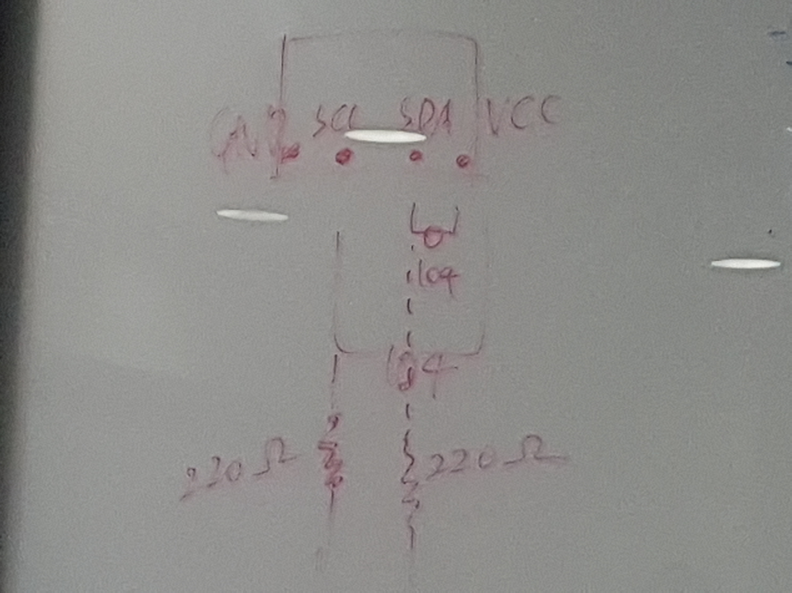

불안정하다면 SCA, SDA에 저항 꽂을것

GIO까지만되는사람은 1k 저항 추가할것

mcu 연결하고 디버그
되면 레드버튼 클릭

mcu연결 - putty 실행
TMS570 load-serial
(mcu연결)아두이노-tools-port로
serial- port설정(ex./dev/ttyUSB0)하고-save - 메시지출력

